Core Vocabulary

🧱 What is Core Vocabulary
# Source: AI Source: Provided by: [Data Path: Persons Table -> ID Column: 1, Name_En Column: Motasem Essam] -> From: [Chatgpt (GPT-4-turbo)] on [7/30/2025]
Core vocabulary consists of a small set of high-utility words that are frequently used across all contexts and are essential for basic communication. These words cover a wide range of meanings and functions, and they make up the foundation of both spoken and written language.

✅ Key Features:
# Source: AI Source: Provided by: [Data Path: Persons Table -> ID Column: 1, Name_En Column: Motasem Essam] -> From: [Chatgpt (GPT-4-turbo)] on [7/30/2025]
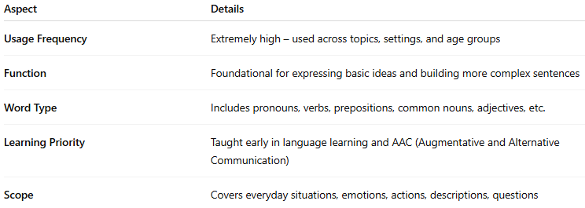
Aspect | Details
Usage Frequency | Extremely high – used across topics, settings, and age groups
Function | Foundational for expressing basic ideas and building more complex sentences
Word Type | Includes pronouns, verbs, prepositions, common nouns, adjectives, etc.
Learning Priority | Taught early in language learning and AAC (Augmentative and Alternative Communication)
Scope | Covers everyday situations, emotions, actions, descriptions, questions

🧠 Examples of Core Vocabulary Words:
# Source: AI Source: Provided by: [Data Path: Persons Table -> ID Column: 1, Name_En Column: Motasem Essam] -> From: [Chatgpt (GPT-4-turbo)] on [7/30/2025]
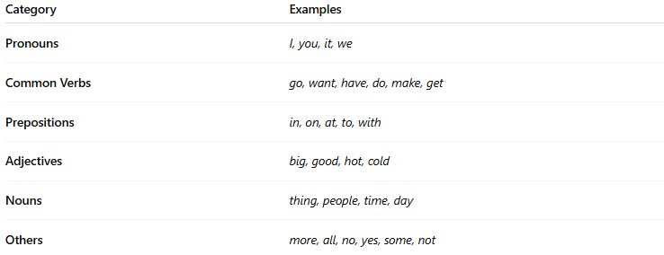
Category | Examples
Pronouns | I, you, it, we
Common Verbs | go, want, have, do, make, get
Prepositions | in, on, at, to, with
Adjectives | big, good, hot, cold
Nouns | thing, people, time, day
Others | more, all, no, yes, some, not
📌 Core vocabulary often overlaps with high-frequency vocabulary, but it emphasizes functionality and versatility over mere frequency.

👤 Who Uses It?
# Source: AI Source: Provided by: [Data Path: Persons Table -> ID Column: 1, Name_En Column: Motasem Essam] -> From: [Chatgpt (GPT-4-turbo)] on [7/30/2025]
- Early language learners
- ESL/EFL students
- Children and emergent readers
- AAC users (e.g., speech-generating devices)
- Curriculum designers and teachers

📌 Related Vocabulary Types:
# Source: AI Source: Provided by: [Data Path: Persons Table -> ID Column: 1, Name_En Column: Motasem Essam] -> From: [Chatgpt (GPT-4-turbo)] on [7/30/2025]
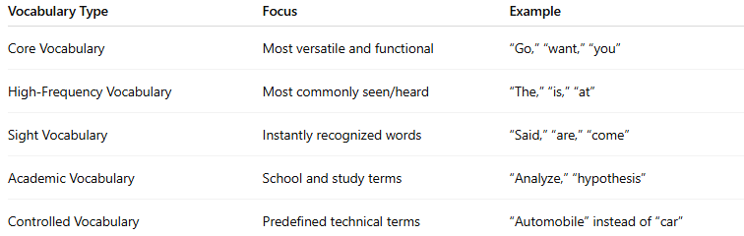
Vocabulary Type | Focus | Example
Core Vocabulary | Most versatile and functional | “Go,” “want,” “you”
High-Frequency Vocabulary | Most commonly seen/heard | “The,” “is,” “at”
Sight Vocabulary | Instantly recognized words | “Said,” “are,” “come”
Academic Vocabulary | School and study terms | “Analyze,” “hypothesis”
Controlled Vocabulary | Predefined technical terms | “Automobile” instead of “car”

